Coastal Path Half Marathon
The route starts and finishes on the coastal path at Preston Island. Parking is available on street in Newmills, and in Culross east car park by the primary school.

The plotaroute link for the route can be found here and a screenshot of the route map is attached below
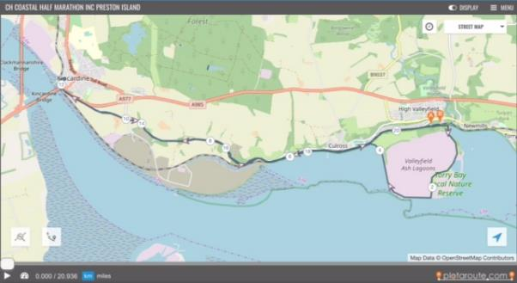
Summary
The route essentially leaves from the railway bridge by the car park for Preston Island, loops clockwise around Preston Island before heading out to Kincardine. At Kincardine, the route goes under the road bridge and around a small green in Kincardine village where we plan to have a water station. The route then returns along the coastal path back to the railway bridge at Preston Island car park. On the return leg, the route goes straight to the railway bridge and does not loop around Preston Island.

Route Description
Start here under the bridge and run towards and through the two wooden gates to go clockwise around Preston Island. Follow the tracks closest to the high wire fence surrounding the ash lagoons.
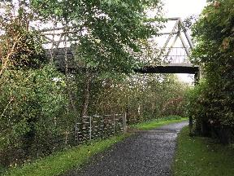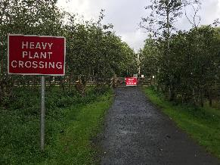
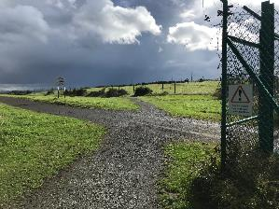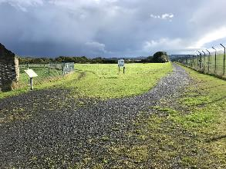

At the end of the Preston island loop, go through the double gate over the railway line and immediately turn left onto the tarmacked coastal path, backed by high hedges. The railway is mostly disused since Longannet closed but pay attention when crossing.
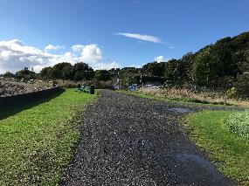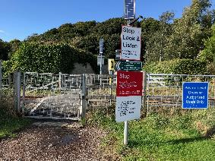
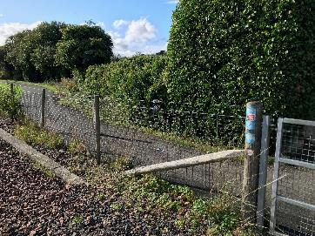
Continue along the coastal path, past Culross, (toilet available if needed in the children’s playpark) and up a series of undulations going past farm buildings and Longannet.
At the entrance road to Longannet, cross the road carefully (there may be demolition traffic so be aware) – take a slight right and then a left to continue along the coastal path route. You should now be running alongside a timber laydown yard.
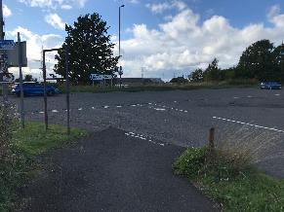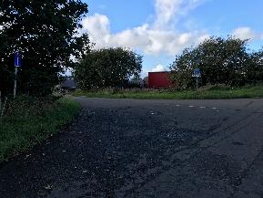
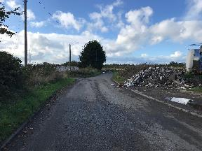

When you reach the end of the coastal path at Kincardine, continue under the road bridge. You are now on a quiet road mostly used for access, but be aware of traffic.
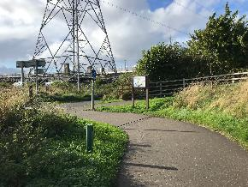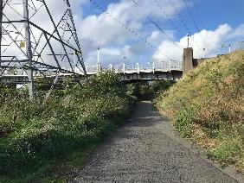

Turn left onto Forth Street. Follow the road around with the houses on your right hand side until you come to a green with a playpark and cream coloured senior citizen facility. The water station will be located here.
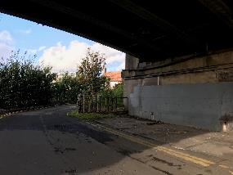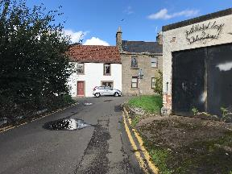
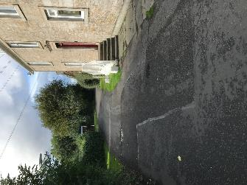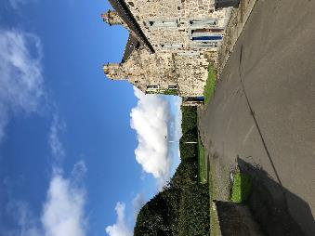
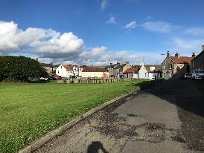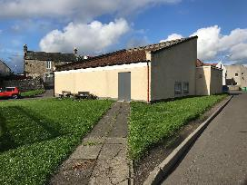

Run on the path between the playpark and the cream building and then cross the grass (anti clockwise direction) to reach the corner of Forth street, and then return via Forth street to go under the Kincardine Bridge again.
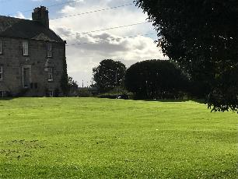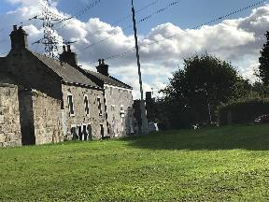
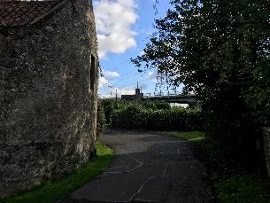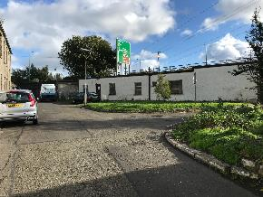

A close up of the route in Kincardine is attached below.

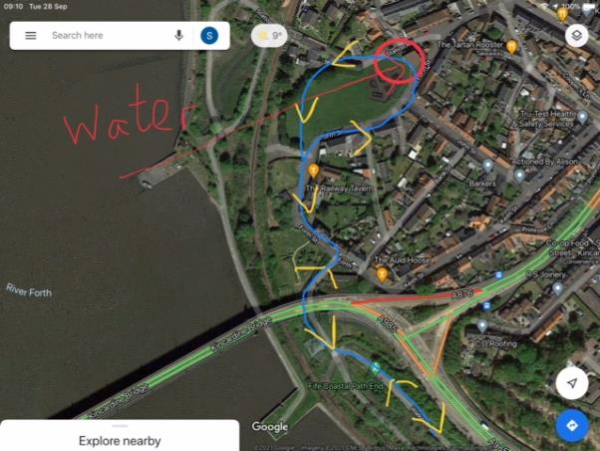
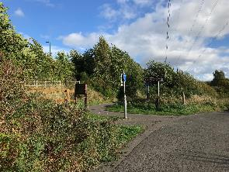

Return along the coastal path taking care again at the road crossing at the entrance to Longannet. 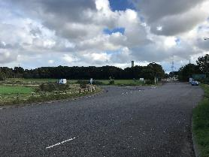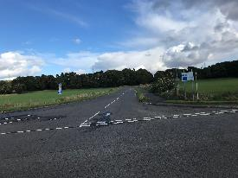
Continue along this undulating section of the coastal path until you again cross the railway line at the gate at the eastern end of Culross. Turn left, and head along the track that runs parallel to the railway line. This is the final mile of the run, heading back to the Railway Bridge and finish.
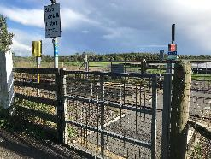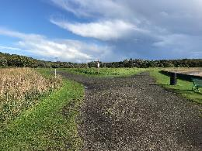
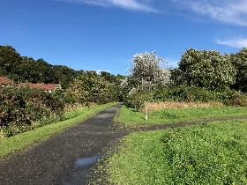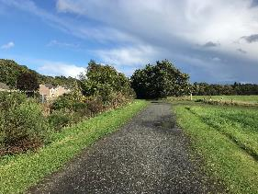
The finish line is under the railway bridge
