Sue Walker’s 2022 West Highland Way Race report

My second West Highland Way Race

Having run the West Highland Way in 2012 in 30:18, to celebrate turning 50, I wanted to run for another goblet to celebrate turning 60. I was delighted to get lucky in the ballot and be offered a place.

I’ve done support for Fiona Rennie and Pauline Walker most years since 2008 so I broke it gently to Fiona that I wouldn’t be in her crew this year. Between us, we recruited a great pool of willing supporters both novices and experienced supporters, and managed not to poach each other’s crew! David Greig was planning to support me but family duties meant he had to withdraw. Fortunately Gail Murdoch and Steven King were willing to rise to the challenge of doing my support. Gillian McCracken was meant to be supporting too but her bad back made travelling, never mind running, a problem and she also had to withdraw, leaving Gail and Steven to do running support and Ken on food and feet. Jill Wallace (my niece) and her boyfriend John Flannery were doing first half support handing over to Ken at Auchtertyre. Both Jill and John did a great job in support and enjoyed becoming part of the West Highland Way family.

Race Build up

My training had gone well over the last couple of years, and especially since I retired in 2020 allowing me to fit in more regular running. My build up events in 2022 were the Chatelherault 6 hour event in February in foul weather (27 miles), The Woldsman in Yorkshire in April (51 miles), the inaugural Formantine and Buchan 12 hour event in early May (54 miles) and the Edinburgh marathon at the end of May. I was happy with how things were going but less than happy with picking up Covid just after the Edinburgh marathon Fortunately, I got off very lightly with just very mild summer cold symptoms, and was completely Covid free before the event (negative tests and resting heart rate normal) but I was worried about the potential impact on my race More on this later.

Immediate race preparation

With food and kit packed, and race details committed to print, I went to bed on Friday afternoon to rest. To my amazement I slept solidly for 3 hours and even managed a decent snooze in the car after registration. Ken had driven me through to Milngavie and swapped everything to Jill and John’s car. After the race started, Ken then headed off to catch some sleep in a wigwam at Auchtertyre. Registration was quiet – not even a queue for the loos – and even the car park felt quiet until just after midnight when runners and crew and race volunteers seemed to appear out of nowhere. Race briefing was at 12:45. We had a minute’s silence thinking of absent friends and then the race was started by Katrina Kynaston. It was a relief to get started!

Milngavie to Rowardennan

Fiona and I started together in Milngavie. We had discussed our race tactics in advance and had agreed that we would not plan to run together as neither of us wanted to hold the other one back. We thought we would run a lot together as we do run at very similar paces but we had no intention of forcing anything. We both set off at an easy pace. I was wearing a Corus watch to record my run and was also wearing a Fitbit specifically to monitor my heart rate. I knew from reports from others that one consequence of Covid is a tendency for erratic or racing heart rate. If either happened, I was fully prepared to withdraw and my crew would collect me. My heart rate rose to my normal running level in the first couple of hours before dropping down as I mixed walking and running. (My plan was consistent effort walking the hills and running the flats and downhills.).

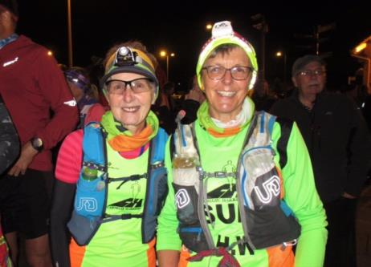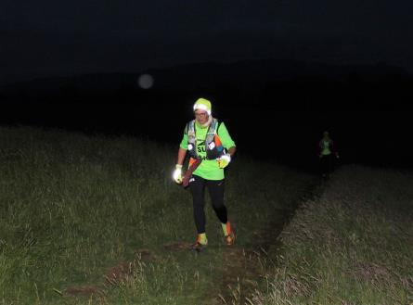

I was glad to be running alongside Fiona as we ran past the Carbeth huts. Otherwise I would have thought I was hallucinating when I spotted a couple standing outside in their jammies cheering runners as they went past at around 2 in the morning! I met Jill and John at Drymen picking up a couple of pieces and jam (homemade raspberry) which went down a treat. I took off my head torch here but forgot to give to to Jill! It was a lovely morning and the views from the top of Conic hill were stunning. I followed the scout group down into Balmaha – the group had been doing a mid-summer camp. John had made me a flavoursome aeropress coffee and John and Jill chummed me out of Balmaha as I ate my porridge. I caught up with Fiona and Pauline doing the same and Fiona and I headed off together to Rowardennan. Again, Fiona and I took it steady to Rowardennan, arrived together and were met by our crews. I changed my socks here and shook grit out of my shoes and picked up another piece and jam – and a piece and marmite – (fair to say the jam went down better than the marmite!). Jill and John packed up and headed off to the wigwam at Auchtertyre for a well-earned sleep.

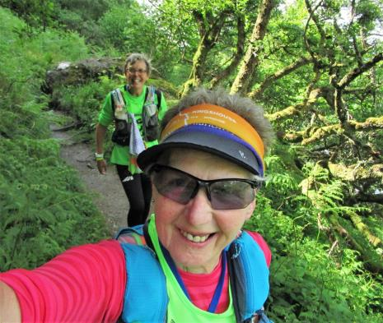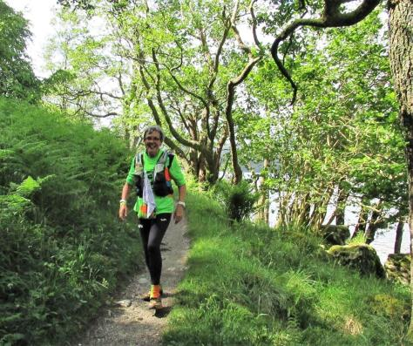

Rowardennan to Beinglas

Fiona and I ended up running this section together. Again, not on a planned basis but just our running paces are fairly similar.

Leaving Rowardennan, Fiona and I were checking our watches and checking pace against check point cut offs. We left Rowardennan at about 7:30am (27 miles) and our next checkpoint off was Beinglas at 1pm. 5.5 hours for 13 miles seems very reasonable until you realise that 6 miles is along the loch side where 20-30 minute mile pace is admirable for us (we’d taken 6.5 hours to cover the 27 miles to Rowardennan). Fiona and I had a real fear/worry/ concern that we’d get timed out at Beinglas and we pushed hard along the loch side.

After Beinglas, check point cut offs are more generous so if you get to Beinglas without over extending, then the later cut offs are less of a concern. This is a real issue for the runners in the back of the field. How hard you push effort wise up to 40 miles has an impact on the pace you can sustain for the final 56 miles. Those who prefer to run at a fairly consistent effort, need to run at a higher effort in the first ‘half’ to meet cut offs, and then can return to a slightly easier effort to stay within the cut offs in the second ‘half’.

The low road along the loch side from Rowardennan to Inversnaid was new to me. A lumpy, bumpy, technical loch side trail which gave my flexibility a test! The only real downside for me was I didn’t have a sense of how far we’d travelled and how far there was to go. We worked together keeping the pace going till Inversnaid. Inversnaid was a quick dibber and drop bag collection. Thanks to the volunteers there for assistance with refilling soft bottles. On leaving Inversnaid, we caught up with club mate Karl and followed him along the loch side for a while. He was finding the going tough at this point and eventually Fiona went in front allowing Karl to follow her route up and over the rocks. Shortly before the end of the technical bit, we both pulled away from the small group who were running together. We worked out that we had time for a very brief tribute to Dario at his post. Fiona had her whisky and I had invested in a miniature hip flask filled (appropriately) with home-made Sloe Gin. Our hard work along the loch side paid off and we arrived in Beinglas with 32 minutes to spare. It was good to see another club mate Ria volunteering here, and Jonny Fling’s coffee was much appreciated

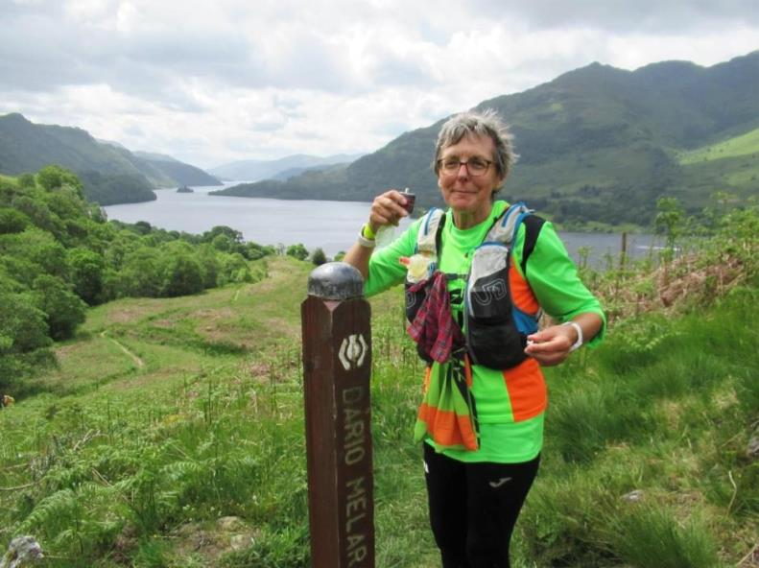
Beinglas to Auchtertyre

Still together, Fiona and I left Beinglas eating our drop bag contents. We stomped up the hill before returning to running the flats and downhills. We both appreciated John Kynaston’s bridge having tried out the diversion and the stepping stones in the past 18 months, though when I gave the handrail a pat I got skelf in my finger

The new gates instead of stiles at Carmyle cottage were appreciated by tired quads as was the carpet smooth tarmac of Cow-Poo-(no-more) Alley. Up and down the roller coaster it was a lovely surprise to bump into Debbie and Karen heading south. It was incredible to see the devastation left by Forestry Commission harvesting just before the road crossing, but new trees are being planted and it should look less desolate soon. For once, we got a clear road crossing on the A82 and we continued trotting into Auchtertyre. It was great to see friendly faces, and to see Ally K who had walked out to meet us. I dibbed in and then had to double back to Ken’s car for support. (He had been staying in the wigwam so his car was parked as a resident rather than as support crew). Ken had my soup ready and tried to deal with a blister on the side of my foot. He drained it and applied a compeed.

I was told that I needed to carry and probably wear full body waterproofs from Bridge of Orchy as bad weather was coming in. Up till then the weather had been patchy. There had been 25-30% chance of rain forecast and what that meant in practice was that we had 15-20 minutes of showers per hour and then the sun would come out to warm us up and dry us off again. Up until then, I hadn’t felt the need to put on a jacket at all and long sleeves were pushed up and pulled down frequently.

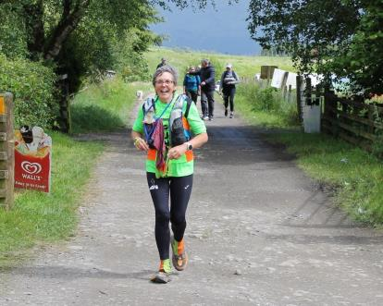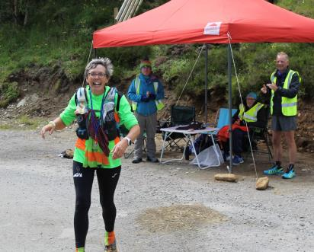
Auchtertyre to Glen Coe

I was ready to go before Fiona, and for the first time since Milngavie, we parted company. Donna was joining her on this section and I was getting Gail’s company from Tyndrum. I expected to run with Fiona again but didn’t see her till the finish. I ran with Robin Pate for a while. He had knee problems and had to pull out at Bridge of Orchy.
It didn’t take long before I arrived at Tyndrum and was joined by Gail (already in full waterproofs). We blethered our way up the hill, and then down under the railway. When I was running, I was kicking stones and my toes were feeling tender, so mostly I was walking unless the path was very smooth. So saying I was moving along between 15-17 minute miles and running really wasn’t much faster than fast walking.
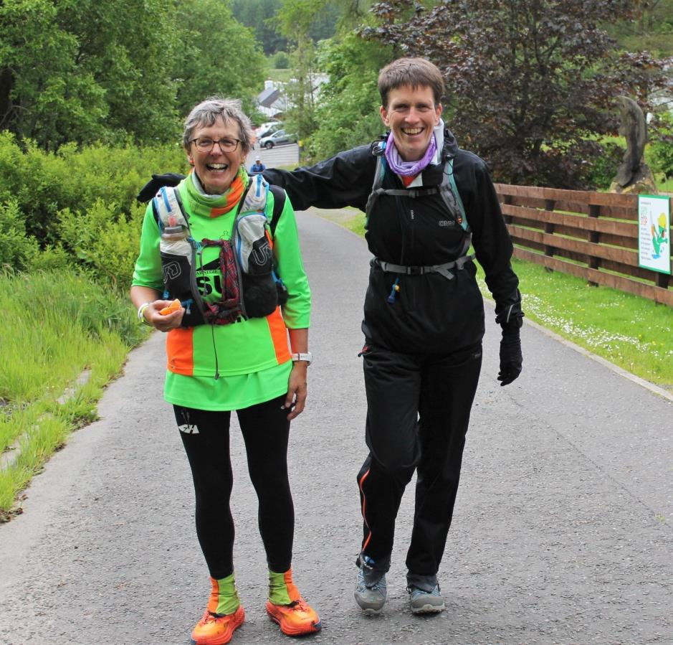

Steven walked out to meet us before Bridge of Orchy and I asked him to find out if I could use the loos in the hotel. I managed to take advantage of the hotel loos (we didn’t know there were portaloos down by the bridge) and was met my crew at the hotel too. We had expected to meet down by the bridge as we thought only campervans were banned but it turned out that no vehicle access to the bridge was allowed. I put on my waterproofs here. I scoffed a pot of rice pudding and ate a tuna fish sandwich as I climbed out of Bridge of Orchy.

We bumped into fellow Fifer Stephen on our way out of Bridge of Orchy. He was out supporting on the Way. It was good to see Mike Raffan take on jelly baby hill duties (formerly Murdo’s mount) – he had a long cold shift there but it really is appreciated. I was still kicking stones when trying to run so we mostly stomped down to Inveronan before getting a good run on the tarmac round to Victoria Bridge. Helena had challenged Gail to get a photo of me looking grumpy at some point in the race so I had a go to try to help Gail win the bet. (Helena wouldn’t pay up as she worked out I was in on the bet!) It was hard though as I really was enjoying myself despite the wind and rain.
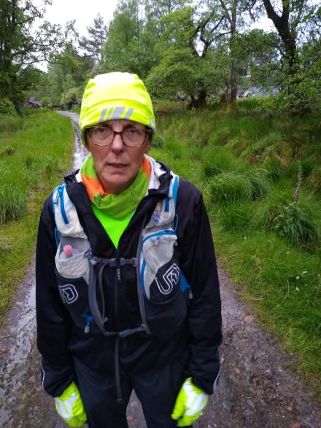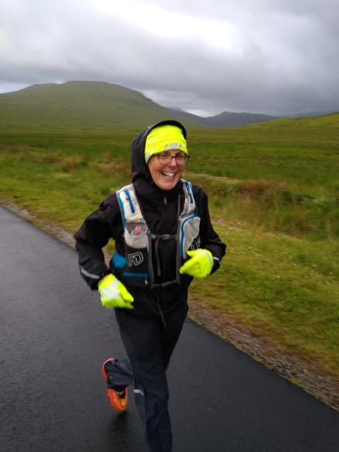
As we got onto Rannoch Moor, my guts starting churning and I needed a couple of pit stops before Imodium kicked in. The wind and rain had properly started and I was glad of good waterproofs. It didn’t seem to take too long before we were descending into Glencoe – amazing what good company does to make a stomp fly by! After dibbing in, I headed up to make use of a proper toilet and change into fresh waterproofs. I also brushed my teeth here and it’s wonderful how awake and alive you feel after that, even if you are tired. I also added a new top and fleece to keep me warm through the night. I forced down a pasta pot and headed out into the night with Steven for company.

Glen Coe to Lundavra

I ran down the nice smooth ski access road before settling in again for a stomp to Kinlochleven. Once we were off the tarmac, I tried leading the way with Steven behind but quickly realised I got on better following him. The climb up the Devil seemed never ending. It was quite something though to see the reverse sweepers running quickly downhill to Altnafeadh and then come right back up again! Going up felt a real struggle and I felt (correctly) that I was at my slowest. I had to take frequent little stops to get my breath back before continuing up and up. It was a surprise to see a tent at the summit and to get a midnight ‘Well done’ shouted out from the occupant. I later discovered it was Daniel Kershaw having a WHW adventure with his young son. Following Steven – a good hill runner – was really helpful as he’s sure footed and picks a good route on stony tracks. The rain was relentless as we climbed making it hard to see through my glasses. It eased off a good bit as we dropped down into Kinlochleven. I nibbled some pro plus and paracetamol as we descended. I dibbed in and visited the loo while Steven went to find Ken and Gail.
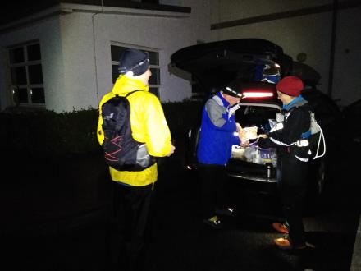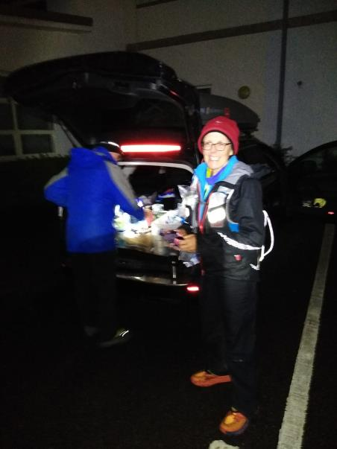
Ken had a mug of Horlicks ready and that was easy to drink. I tried to eat a porridge pot but only managed about half so Ken gave me a jam donut to eat instead. It was a bit stale but I managed to eat the jammy and sugary bits before leaving the rest for the birds. The rain was off by now though still windy. We climbed out of Kinlochleven and as we reached the top of the zig zags I looked back to Kinlochleven and the descent from the top of the Devil. I was surprised to see complete darkness. Usually when I’m there I can see head torches in the distance. We set a good pace walking over the Larig Mhor passing a couple of runners as we went. Again, Steven’s route picking was great and he found stepping stones across the endless burns while I followed in his footsteps. Only occasionally did I need to add an extra step – his legs are quite a bit longer than mine! Jeff Smith’s refreshment stand and cheery welcome was missed this year. It’s always a welcome site and you know the turning point towards Lundavra isn’t far away.

With no signal at all on Larig Mhor, we were unable to alert Ken and Gail to our approach to Lundavra. I was moving well at this stage and arrived in Lundavra about 45 minutes earlier than the timing tracker was predicting. As a result, Ken was at the bottom of the access road. I dibbed in and carried on – no point in waiting. Steven ran down to Ken and picked up a bag of supplies which he brought up to me, while Gail who was supporting me to the finish gave chase too.

Lunduvra to Fort William

Gail soon caught up with me and we set a good pace. It wasn’t long before I was too warm with all my layers on and I pulled off my water proof jacket and fleece. I left the waterproof trousers on though as removing them felt like too much hassle. We passed another couple of runners here.

Once we eventually reached the top of the fire break, I managed occasional shuffles but really I was every bit as quick walking. Tim Downie passed me here after a wee sleep in Kinlochleven but I think he was the only runner to pass me between Glencoe and the finish.
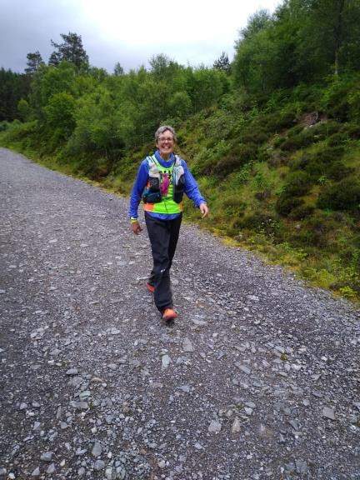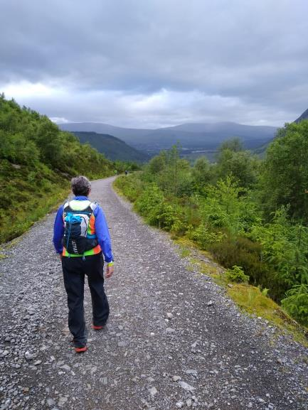
Once we reached Braveheart car park and tarmac, I was able to break into a run (shuffle) and I ran most of the remaining section to the Nevis sports centre.

I finished in 30:37, some 19 minutes slower than in 2012, but with the addition of the low route along the loch side and the extra 0.8mile at the end. I was very, very happy with that.

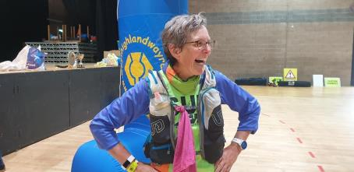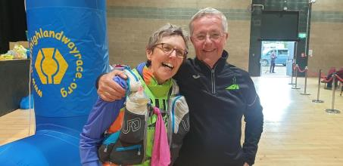
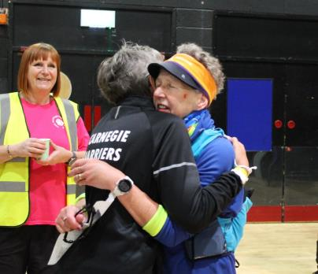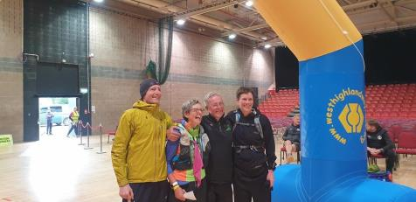
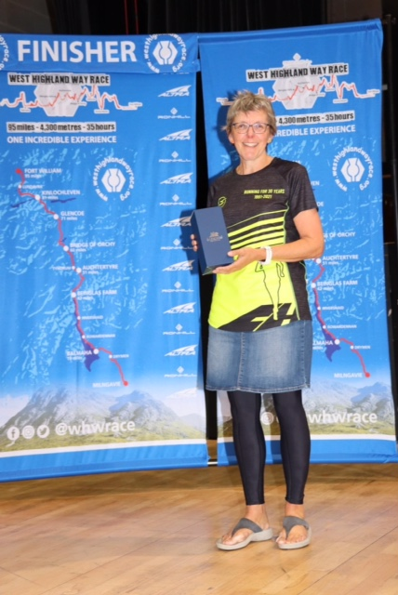

Key Points

- Support crews are the best! I was very fortunate to have Ken, John and Jill fuelling and caring for me and Gail and Steven running with me.
- My fuelling and drinking was fairly good. Home-made raspberry jam pieces are wonderful. Pasta pots and porridge pots are necessary evils and provide fuel - but taste horrible. Pockets stuffed with toffees and fruity sweets are a great back up. Tesco’s salt and pepper nut pots make a tasty change from sweet stuff.
- I’m very prone to blisters and have worked hard at improving foot care. Applying compeeds to blister weak spots in advance helps, but if you still get blisters despite this, there isn’t a lot you can do other than put up with it.
- Carrying Imodium and hand sanitiser was sensible.
- Aeropress coffee is much nicer than instant. Flat coke is great. Active Root tastes good and is pleasant to sip. With a few different flavours available, it wasn’t monotonous.
- Showers at the the Nevis Sports centre are awful – I encouraged Fiona to go to the leisure centre and pay for a decent shower!
- Corus watch battery is every bit as good as is claimed.
- Covid didn’t seem to impact me much though perhaps made me more cautious in my running. I monitored my heart rate throughout the run and saw nothing unusual or alarming. (I would have stopped if I had). I also monitored my resting heart rate pre and post Covid and again, nothing untoward was spotted. See the photos below (90 days of resting heart rate and race heart rate)
- Thanks to Fiona Rennie, Pauline Walker, Gail Murdoch, Stuart McFarlane and Sylvia McGouldrick for the photos.
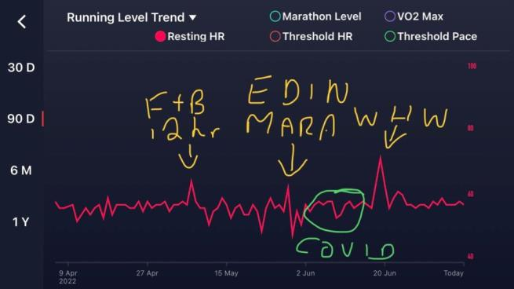
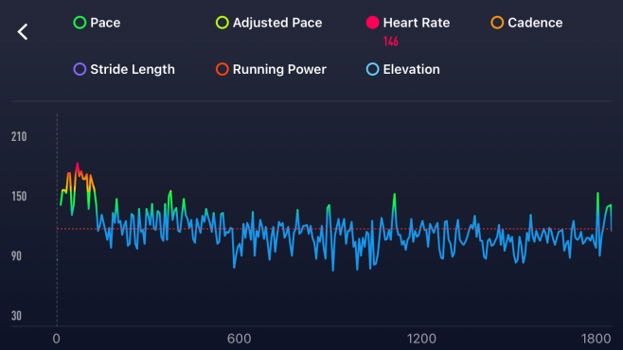

Compare and contrast 2012 and 2022

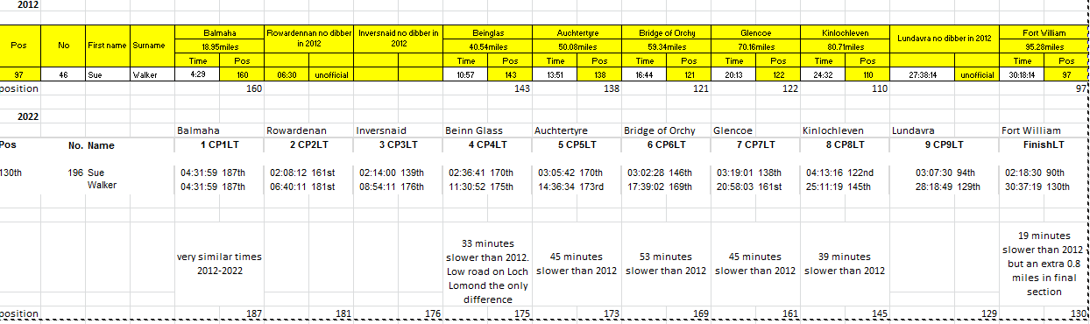
In 2012, 172 runners started and 119 finished – a 30.1% DNF rate. I finished 97th from 119
In 2022, 196 runners started and 155 finished – a 20.9% DNF rate. I finished 130th from 155.

