Carnegie Harriers Festive Forest Run
Saturday 16th December 2017

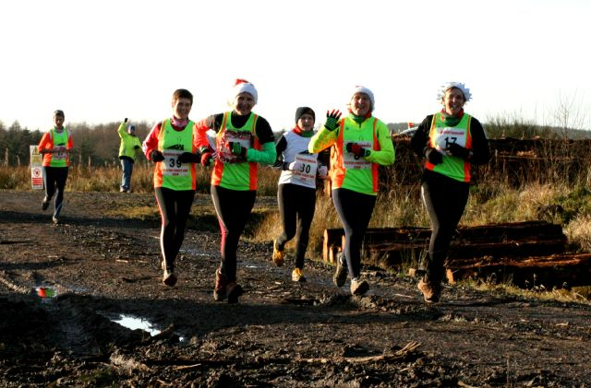
Our annual Festive Forest Run within Blairadam Forest takes place at 12:30pm on Saturday 16th December.
(we will also be including an early start time of 12:15pm again this year, limited start list)

The course is approximately seven miles of forest trails with a few hilly sections and the possibility of mud and/or snow underfoot.

This run is for club members only and although there are a few basic prizes awarded to the respective winners the emphasis is on encouraging everyone in the club to take part. Please complete the entry form and return it by Thursday 14th December.

Remember that there will strictly be NO ENTRIES ON THE DAY.

Anyone willing to help with the run should contact Barry Davie by email at barrydavie@yahoo.co.uk or on 07753 377444.

