Carnegie Harriers



# Annual Report and Financial Statements

# for the

# Year ended 31st March 2024

# Charity Number SCI051520

# Carnegie Harriers

# Trustees’ Annual Report

# Year Ended 31st March 2024

The Board of Trustees have pleasure in presenting their report together with the financial statements and the independent examiner’s report for the year ended 31st March 2024.

## Name and Address

Carnegie Harriers c/o 8 The Wellheads, Limekilns, Dunfermline KY11 3JG

## Constitution and Purpose

Carnegie Harriers is a Scottish Charitable Incorporated organisation – No SCIO 51520

Carnegie Harriers’ principal objective is:

To encourage and promote participation in the sport of running.

## Trustees

Alan Murray President

Sue Walker Secretary

Brian Miller Treasurer

Sarah Wellcoat Welfare Officer

Kathryn Fairfield

Kerry Hunter

Nicole Jackson

Val Macaulay

Kieran Morgan

Alistair Nelson

Gordon Henderson

Kevin Spowart

No trustees resigned during the year ended 31st March 2024

Approved by the Board of Trustees on 13 May 2024 and signed on its behalf by:-

Sue Walker Secretary

**CARNEGIE HARRIERS ANNUAL REPORT 2023/24**

Membership on 31 March 2024 stood at 151 (147 full and 4 associate members), an 18% increase on 2023. The club continued to attract new members throughout the year.

At the start of 2023 we successfully launched “Couch2Carnegie”, a jogScotland style group aimed at those new to running or looking to get back into the sport. Almost half of those who attended the eight-week programme on a regular basis have now joined the club as full members. A second Couch2Carnegie group is planned and will launch mid-April 2024.

The “Return to Running” group to offer an alternative to full club training to those members returning after injury or long-term illness, tapering for a big event or otherwise looking for a less intensive session. It has been well supported over the year.

These initiatives complemented our regular twice weekly sessions and we actively encourage prospective new members to come along to our training sessions for several weeks before committing to joining the club. Training is delivered by a training group comprising a Level 2 Coach in Running Fitness and several Leaders in Running Fitness. The club supports members who wish to work towards these qualifications.

Throughout the year we organised a members’ only competition series embracing road, trail, cross-country and hill races both locally and nationally. The revised format with more local, club organised events and fewer events overall has proved popular with many club members being inspired to try out new races and new types of events. The aim is to cater for as wide a range of interests and abilities as possible, and encourage members to try different disciplines, whilst trying to reduce/restrict the costs of competing at this time.

During 2023/24 we were, once again, able to host the Devilla Forest Trail races and the Graham Clark Memorial race. Both events attract members from across the central belt of Scotland and beyond and raise money for local charities.

The club’s success is due, in large part, to its volunteers. The trustee board has worked on several initiatives to improve communication within the club and promote our activities to a wider audience using social media, as well as overseeing the day-to-day running of the club. Over 60% of club members have volunteered at least once in the past year to support not only club activities but external events as well.

Over the coming year, we will continue to work on our training provision, introducing new sessions and training venues and recruiting more people to lead the sessions. We will aim to recruit new members to the club, by catering for different levels of experience and ability and support existing members who may be finding it more difficult to get out and run.

# Carnegie Harriers (SCIO 51520) – Treasurer’s Report 2023-24

### **Treasurer:** Brian Miller

## Introduction

I hereby present the Treasurer’s Report and Annual Accounts, as independently reviewed by Peter Fotheringham MA (Hons), CA (see Appendix #1).

The Harriers’ financial year follows a consistent pattern, with membership income and race events occurring at the same point of the calendar each year.

With activities returning to a post-COVID norm, the success of the annual Devilla race helped the Club post a financial surplus of £3,300 this year.

## Income

Membership income received during the year is as detailed in the Notes to the Accounts (see Appendix #3). The majority of members signed up via Entry Central, where the Club met the 5% Admin Fee.

Membership fees were increased by 10% this year, reflecting the increased cost of living, generally, and to meet the increased costs that the Club faces on certain areas of expenditure. It was great to see so many renewals and to also welcome a number of new faces during the year.

Both of our flagship races were very well attended this year and both generated profits. 100% of the Graham Clark profits (£1,200) were donated to charity, with £1,000 of Devilla profits also being donated. After donations, Devilla generated a surplus of £2,600 to the Club.

Clothing sales were significantly higher this year, as there was a concerted effort to sell old clothing items to members at a reduced price.

A Grant of £400 was received in December 2023 courtesy of the employers of a member. This grant covered the purchase of a new gazebo/tent that was primarily used for Cross Country meetings.

The club have organised a social event in Aviemore in November 2024. Deposits were paid to the club by all members planning to attend. This was paid to the Aviemore Youth Hostel to secure accommodation for the weekend - an excess of £140 is retained by the club, but this will contribute towards the total costs of the trip, as incurred.

The Christmas Social Event was another source of income this year - organised via Entry Central. This was essentially a Not-for-Profit event, but ran a deficit of £300 this year, as the Trustees agreed to subsidise this amount for members this year.

## Expenditure

There are a number of membership expenses that are incurred every year as part of the club’s operations. Scottish Athletics Affiliation Fees, GP Prizes, Trophies, Website, etc, and these were much in line with expectations. Overall, membership costs were higher than 2023 (Appendix #3), mainly due to the timing of the GP prize-giving in each year and an increased number of prizes awarded.

Expenses for Graham Clark and Devilla were in line with budget.

Costs were also incurred for the social event, primarily the venue hire and catering costs at Pitreavie Golf Club. These were largely offset by ticket sales to members.

Other costs primarily related to the Zoom subscription we have relied upon this year for some of our Committee meetings.

## Independent Review

The independent review was performed remotely via email, with documents shared electronically, consistent with the approach of recent years.

## Conclusion

This has been a good year financially for the club, reporting a healthy surplus. The surplus funds are reinvested in the club to maintain our long-term financial security. The club will maintain a financial reserve to meet costs and liabilities occurring due to unforeseen circumstances. For example:

1. the need to replace club assets if destroyed or damaged;
2. unexpected, late cancellation of the Devilla Forest Race.

The club enters 2024-25 in good shape and looks forward to another successful year.

I would like to issue thanks to the committee members for their support and diligence in ensuring our finances remain so well controlled.

Brian Miller

### Appendix #1 – Independent Review

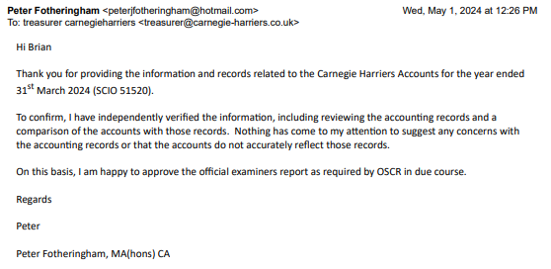

### Appendix #2 – Income and Expenditure Account

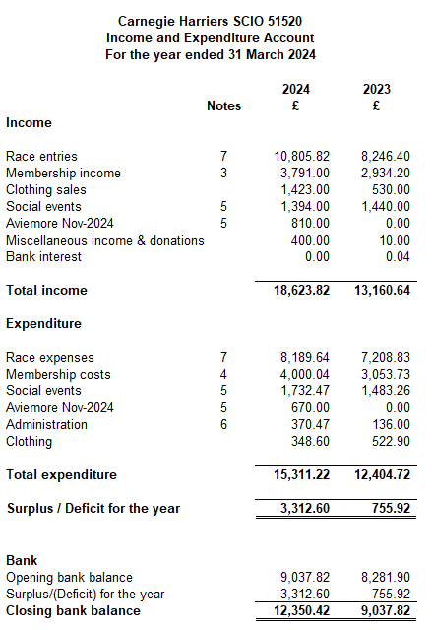

The notes below on pages 8 and 9 form an integral part of these accounts

Approved by the Board of Trustees on 13 May 2024 and signed on its behalf by

Alan Murray, President Brian Miller, Treasurer

### Appendix #3 – Notes to the Accounts

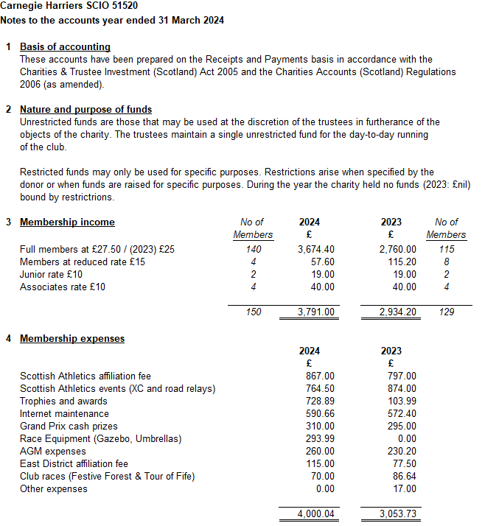

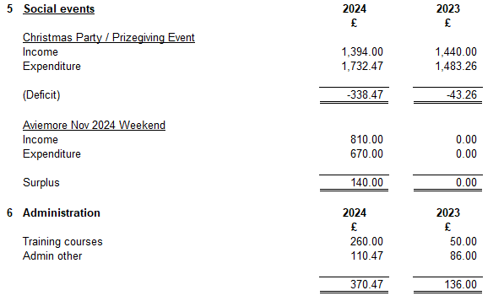

### Appendix #4 – Race Summary

### 

### Appendix #4 – Club Assets (Draft)

