**CARNEGIE HARRIERS ANNUAL REPORT 2023/24**

**INTRODUCTION**

This 2024 report covers the period from 1st April 2023 to 31st March 2024, in line with our financial year. The document comprises reports from trustees on their specific areas of responsibility together with a review and comments from club president Alan Murray.

# President’s Report (Alan Murray)

## Introduction

2023/24 has continued to see the club go from strength to strength, with increased membership, great attendance at training, more participants and completers in the GP and importantly some brilliant running/racing from 5ks to 24 hour+ ultras.

A refreshed Trustee board, post official SCIO recognition, brought new ideas and a new perspective in terms of training, the grand prix, club promotion, communications, clothing etc. with all aspects well received by the membership.

The Trustee board has also tried to be more open over the last 12-18 months, canvassing members’ opinions to help drive change and ensure as much membership involvement in key decision making as possible.

## Membership/Fees

Members continue to join the club on a regular basis, which is very positive, and we have been pleased to welcome a few new members from the C2C group (more on that later) as well as some returning members who had left or let their memberships lapse for whatever reason.

Current membership stands at a very healthy 151 (147 full and 4 associate), which is up on the 134 at this stage last year. Thanks for continuing to support the club.

Last year, you will recall that we increased the yearly subscription to £27.50 to help cover increased costs. The Trustees discussed the fees for the coming year and have decided to leave them at current levels for 24/25. More on this at the AGM.

## Grand Prix

This past year included a much-needed revamp of the club grand prix based on members feedback to the survey sent out early in 2023. We reviewed the feedback carefully and tried to take in as many opinions as possible, resulting in a GP with more streamlined events, making completion simpler and increasing members’ participation. Moving to a single GP of 20 events across 5 disciplines, whilst still serving the needs of the All-Rounders Competition (ARC) proved a great success. A breakdown of the grand prix is detailed later in this overall members’ report.

Normally at this point, I’d take the opportunity to say well done to all winners and completers, however, this year we will be announcing the winners at the prize-giving which follows the AGM.

## Training

Training continued to be well attended throughout the year, with great numbers at many of the sessions and lots of new faces. It was also great to see many members consistently attend training every week, as that is how you get the most benefit from the sessions. The new training leads (Kathryn and Nicole) really helped to keep the sessions consistent and beneficial, whilst ensuring a qualified trainer was available for all sessions. The training group are always on the lookout for new training leads to help spread the load, therefore we are pleased that Sarah Marshall, Steve Adam, Gordon Henderson, Michelle McNiven and Gail Beveridge have passed the required training. We look forward to seeing them lead sessions very soon. Thanks once again to Lesley Reynolds in particular and the training group for all their hard work again this last year. It is very much appreciated and is the bedrock of any successful running club.

## Couch To Carnegie and Return to Running Group

On the back of the success of last year’s inaugural Couch to Carnegie, we have just launched a second cohort and we look forward to seeing many of those attending, graduating to full Carnegie members in the summer. Thanks go to Gail Beveridge and Val Macaulay, ably supported by Kathryn Fairfield, for leading the second round of Couch to Carnegie and to all members who have turned up, and continue to turn up, to support and help with the group runs. From the initial C2C graduates, it has been great to see the likes of Katie Kelly, Lorna Kelly, Paul Kelly, Ailsa Campbell and Heather Patterson progress to full training and racing with the club and participating in the Grand Prix.

Our Return to Running group has once again been well attended and has proved a success alongside club training, for those returning from injury or just looking for company and a social run as an alternative to full training.

## Club Racing

It was brilliant to be able to put on the Graham Clark and Devilla Races once again this year, with increased numbers in both races. As always feedback was very positive and really helps showcase the great things the club can do. Thanks to our race directors (Allan, Val and Gordon) for all their hard work in putting these events together and to members for volunteering and supporting. These events cannot go ahead without members support.

We also ran a very successful Festive Forest race in December 2023, with new race directors Nicole and Gordon and I am sure you all agree, they did a great job.

## Racing

It was great to see members taking part in many organised races both locally and further afield, in all disciplines from 100 mile+ ultras to 1-mile sprints. This really shows the great variety and depth of runners that we have in the club. It has also been pleasing to see many members trying new disciplines for the first time such as XC, Marathon and Ultra. Too many great performances to mention here (although there have been a few that deserve a special mention so more on that later). We can see many members have signed up for races throughout the rest of this year. We wish everyone success and hope that all that training pays off and you have the races you deserve.

## Clothing

2023 saw the launch of our first new clothing range for many a year, using local firm The Soccer Shop Direct, as kit supplier and managing online sales.

The new kit has been well received and so far over £1250 has been spent! As part of the deal with TSSD, the club receives what is known as a small ‘kick back’ on all purchases, which all helps to boost club funds. Much of the old stock of kit has been ‘shifted’ this year to make way for the new stock with the added bonus of raising some cash for the club. Thanks to the Clothing subgroup for their hard work.

## Congratulations

As mentioned previously, 5 members completed their Leader in Running Fitness training this year (Gordon Henderson, Sarah Marshall, Steve Adam, Gail Beveridge and Michelle McNiven). Well done all.

Our GP and ARC winners will be recognized at prize giving, but it would be remiss not to mention some of the other club achievements over the past 12 months. It is always hard to mention all the great results this year, so please don’t be offended if your efforts are not specifically called out. Every member who completes any race, deserves a massive pat on the back.

Firstly, some parkrun milestones this past year:

* 50 - Allan Macaulay
* 100 - Shelley Hogg, Lesley Reynolds, Stevie Greer, Barry Davie
* 200 - Joy Gudgin
* 250 - Donald MacLeod
* 350 - John Hynd
* 400 - Kieran Morgan

not forgetting the non-running contribution Gillian Cable has made to Dunfermline Park Run again this year, as well as volunteering at the Victoria Park run in Belfast and at the Belfast Marathon Expo.

Too many great performances to mention in terms of those who achieved age graded race placings, PBs and members who ran their first half marathon, marathon and ultra this year, you know who you are.

However, there were some notable performances deserving of a mention here:

* Lesley Reynolds - Female British Masters V55 champion at Anglo Celtic Plate
* Joy Gudgin - V60 Scottish Masters Champion at London Marathon
* Jamie Harte - First sub 3 marathon at Loch Ness
* Nicole Jackson - 1st place at Smokies
* Fiona Rennie - Completing her 100th! Ultra
* Fiona Rennie - Sri Chinmoy 50k road race F60 Scottish Champion

Well done all!

## Socials

2024 saw our first organised club trip to Belfast and what a successful weekend it was. More on this in next year’s report. Thanks to the marathon subgroup who helped organise the weekend.

We can also look forward to another club trip to Aviemore in November. Thanks to Gail Beveridge and Sue for pulling this together. Again, more on this at next year’s AGM.

The annual Xmas party was, as usual, a great success. Thanks to the Socials subgroup for organising and to the 60 members who enjoyed a night of fun and a chance to get to know folks better in a more relaxed, non-running environment!

## Trustees

Thanks to all the trustees for their great efforts over the last 12 months. It is very much appreciated. It has been great to see many new initiatives kicked off and a freshness to the committee this year, with everyone contributing well.

Most trustees have indicated a willingness to stay as part of the board for 2024/25 and we are grateful for them for giving up their free time to help support the club.

I’d like to thank Alistair Nelson for his service as a trustee over the past two years. Gordon Henderson is also standing down as trustee and we thank him for a truly excellent contribution in the past year as men’s captain and race director for the Festive Forest race.

If any member is unsure of making the commitment to join the full Trustee board, then there is always the opportunity to be co-opted in for periods of time to help with specific tasks.

My intention is to not stand for re-election as club president for 2025/26. After 6 years in the role, I feel it is time for someone else to take the reins and drive the club forward. Anyone who is interested, or wants to know more what the role entails, feel free to come and chat at any point.

## Keeping in Touch

The club communication channels have continued to evolve over the last 12 months, with increased use of our Instagram feed and Stack Club App as well as more use of our members and public Facebook pages. We continue to update the website where required. Last year’s plan to have a training and racing calendar on the site to help with your training and racing planning, did not happen, so we will look to get this picked up soon. We will also assess whether there are more opportunities to use the Club app for instant communications.

## Other

Sadly, we lost a valued member in Allan Brannigan in October last year at the age of just 60. He continues to be missed by all, but his memory will live on in the club, with the launch and initial award of the Allan Brannigan “Spirit of Carnegie” trophy.

We launched the club library in 2024 and thank members who donated books to be loaned out. Members also contributed handsomely to various appeals for trainers and T-shirts to be distributed to those less fortunate.

## Conclusion

2023/24 has once again been a very strong year for the club and we continue to go from strength to strength. Engaging more closely with members has ensured more involvement in decision making in terms of deciding GP setup/races, venues for club trips and winners of awards, for example. The trustee board will continue to involve members in helping define the future direction of the club throughout 2024 and into 2025, making the club much more inclusive.

The makeup of the current board is strong, but we always need new folks to come on board and provide new ideas and impetus. As mentioned previously, if interested please reach out to discuss.

We look forward to another great year of training, racing, socials and more during the next 12 months.

Thank you all for your continued membership and support. We wish you all great racing throughout the rest of 2024 and into 2025. Happy running!!

-----------------------------------------------------------------------------------------------------------------

# Treasurer’s Report 2023-24 (Brian Miller)

## Introduction

I hereby present the Treasurer’s Report and Annual Accounts, as independently reviewed by Peter Fotheringham MA (Hons), CA (see Appendix #1).

The Harriers’ financial year follows a consistent pattern, with membership income and race events occurring at the same point of the calendar each year.

With activities returning to a post-COVID norm, the success of the annual Devilla race helped the Club post a financial surplus of £3,300 this year.

## Income

Membership income received during the year is as detailed in the Notes to the Accounts (see Appendix #3). The majority of members signed up via Entry Central, where the Club met the 5% Admin Fee.

Membership fees were increased by 10% this year, reflecting the increased cost of living, generally, and to meet the increased costs that the Club faces on certain areas of expenditure. It was great to see so many renewals and to also welcome a number of new faces during the year.

Both of our flagship races were very well attended this year and both generated profits. 100% of the Graham Clark profits (£1,200) were donated to charity, with £1,000 of Devilla profits also being donated. After donations, Devilla generated a surplus of £2,600 to the Club.

Clothing sales were significantly higher this year, as there was a concerted effort to sell old clothing items to members at a reduced price.

A Grant of £400 was received in December 2023 courtesy of the employers of a member. This grant covered the purchase of a new gazebo/tent that was primarily used for Cross Country meetings.

The club have organised a social event in Aviemore in November 2024. Deposits were paid to the club by all members planning to attend. This was paid to the Aviemore Youth Hostel to secure accommodation for the weekend - an excess of £140 is retained by the club, but this will contribute towards the total costs of the trip, as incurred.

The Christmas Social Event was another source of income this year - organised via Entry Central. This was essentially a Not-for-Profit event, but ran a deficit of £300 this year, as the Trustees agreed to subsidise this amount for members this year.

## Expenditure

There are a number of membership expenses that are incurred every year as part of the club’s operations. Scottish Athletics Affiliation Fees, GP Prizes, Trophies, Website, etc, and these were much in line with expectations. Overall, membership costs were higher than 2023 (Appendix #3), mainly due to the timing of the GP prize-giving in each year and an increased number of prizes awarded.

Expenses for Graham Clark and Devilla were in line with budget.

Costs were also incurred for the social event, primarily the venue hire and catering costs at Pitreavie Golf Club. These were largely offset by ticket sales to members.

Other costs primarily related to the Zoom subscription we have relied upon this year for some of our Committee meetings.

## Independent Review

The independent review was performed remotely via email, with documents shared electronically, consistent with the approach of recent years.

## Conclusion

This has been a good year financially for the club, reporting a healthy surplus. The surplus funds are reinvested in the club to maintain our long-term financial security. The club will maintain a financial reserve to meet costs and liabilities occurring due to unforeseen circumstances. For example:

1. the need to replace club assets if destroyed or damaged;
2. unexpected, late cancellation of the Devilla Forest Race.

The club enters 2024-25 in good shape and looks forward to another successful year.

I would like to issue thanks to the committee members for their support and diligence in ensuring our finances remain so well controlled.

Brian Miller

--------------------------------------------------------------------------------------------------------------------------

# Office Bearers Reports

# Secretary’s Report (Sue Walker)

The many tasks involved in running the club were shared broadly across trustees and club members with Sarah Wellcoat producing minutes of meetings and organising awards, Kerry Hunter and Sarah Wellcoat organising our Christmas party, Nicole Jackson taking the lead in looking after new members and prospective members, Brian Miller promoting the ARC on social media, Val Macaulay processing GP race results and managing GP and ARC tables and Kerry Hunter, Sarah Wellcoat and Val Macaulay organising the prize giving. Thanks go to each of them for stepping up and sharing the load.

# Membership Report (Nicole Jackson and Sue Walker)

During the financial year to end of March 2024, 151 people joined / re-joined the club, made up of 147 adult members and 4 associate members. (In 2023, we had 128 members on 31/3/23 and in 22 we also had 138 members on 31/3/22.) It has been especially encouraging to have attracted 18 new members and 4 returning members since summer 2023, and to see Couch2Carnegie graduates fully participate in the club.

# Women’s Captain (Nicole Jackson)

2023-2024 has been a great year for our female members. We have 66 in total making up 44% of our total membership. We have had 9 new female members join over the past year - a sign that the club is still appealing to new and experienced female runners alike.

Our Women’s Captain has been as involved as possible with regards helping at races, in particular declarations etc at the Cross-Country events. It has been wonderful to see more of our female members getting involved in hill and cross-country racing! The camaraderie amongst our female members is clear to see and this has helped newer members get involved and feel at ease. We have seen some fantastic results across the year, especially from members who have committed to their training and are now reaping the results. It’s a privilege to see and be a part of. Looking forward to 2024 and all the brilliant things we will achieve. As always, if there is anything you would like to feedback or introduce to our female members, please get in touch.

# Men’s Captain (Gordon Henderson)

Hard to believe that’s 2023-24 in the books already!

It has been great to see consistent numbers attend training sessions throughout the year, and for that, I’d like to thank the club’s training leads for ensuring these sessions remain relevant and catered for all.

And a thanks also to members for their continued commitment, who have been rewarded with some fantastic individual and collective achievements at various events, locally and globally.

I’ve really enjoyed the upsurge in cross country participation, with some members trying it for the first time and returning for more! Perhaps it has something to do with our new gazebo!?

I’d also like to thank all those that have volunteered their time and supported the club in any capacity, without you, the success of club coordinated events would not be possible.

My final thanks go to the wider board of Trustees and Office Bearers, in particular co-captain Nicole, for ensuring Carnegie Harriers continues to provide a progressive and supportive platform for the running community.

# Welfare Officer (Sarah Wellcoat)

One welfare incident occurred over the winter in February 2024 which was reported to UK athletics. A runner was bitten by a dog which broke the skin and required a tetanus shot. It was good to see the support offered to the runner, and to the dog’s owner who, we later learned, was also injured in the incident breaking her wrist.

ID verifications for PVG checks have been done for those members becoming Leaders in Running Fitness.

A scheduled club training session was cancelled in December 2023 due to concerns over ice and slippery conditions at the training location.

## Volunteers

With around 150 members, it has been great to see so many club members volunteer to help with trustee board duties, training, races, social events and other club initiatives. More than 60% of club members have volunteered at least once in the past year to support club activities and many have given freely of their time and energy on multiple occasions. Our thanks go to them all.

--------------------------------------------------------------------------------------------------------------------------------------

# WORKING GROUP REPORTS

# Training (Lesley Reynolds/Nicole Jackson/Kathryn Fairfield/Alastair Nelson)

Training attendance has been strong throughout the last year, with numbers consistently being higher than in the previous two years. Two new training venues were identified which allowed increased variety and minimised ‘location fatigue’. Both are within Dunfermline City Centre which enables some members to commute to/from training on foot or bike which assists our desire to become a greener club!

In the last 2 months Gordon Henderson, Sarah Marshall, Gail Beveridge, Steve Adam and Michelle McNiven have all successfully passed their Leadership in Running Fitness course. Gordon, Sarah and Steve will shortly commence leading training sessions, providing resilience to the existing session leaders: Lesley, Nicole and Kathryn.

Lesley Reynolds remains Head Coach and thanks are extended to her for continuing to create training schedules that are enjoyable and challenging.

# Clothing (Kevin Spowart/Kerry Hunter/Sarah Wellcoat)

November 2023 saw the exciting new launch of our virtual club shop through local firm The Soccer Shop Direct, offering all members a range of new club branded kit for all weathers.

This has proved to be a success. In the first 6 months, over £1,250 worth of kit has been purchased which the club will also benefit from through the ‘kick back’ scheme where a small percentage of the gross sales value is returned to the club by way of an instore credit.

The launch of the new club shop provided the perfect opportunity to sell off much of the club’s older stock items whilst also raising some additional cash for the club.

Club vests should still be ordered direct from the club using the enquiries mailbox or by speaking to one of the member support group.

# Social sub-group (Kathryn Fairfield/Kerry Hunter/Sarah Wellcoat)

An all-round excellent year of mixing and mingling within the club. From car sharing to races, a Dunfermline parkrun takeover, summer social and the annual Christmas night out. We look forward to adding parkrun tourism trips into the mix for the 24/25 season.

# Club Hosted Races

In keeping with tradition, the members only **Festive Forest Race** took place on the same day as the Christmas party - Saturday 9th December. 38 runners took part, and the overall winners were Jamie Harte and Charlotte Briggs. Thanks to Nicole Jackson and Gordon Henderson for organising it.

The **Graham Clark Memorial Race** was back at Knockhill Racing Circuit in August. Places sold out within 4 hours of entries opening, with 223 finishers on the night. Conditions were good for running, with Cameron Milne of Central AC setting a new course record of 17.49, well over 1 minute faster than the previous record of 19.01 set in 2014.

Participants enjoyed the customary post-race buffet with the selection of gluten-free, vegetarian and vegan options being particularly well received. This year we were supported by a group of Police Scotland Young Volunteers who helped with marshalling and distributing post-race water. The race aims to raise money for local charities and this year the net profit of £1,200 was shared equally between Dunfermline Food Bank, EATS Rosyth and Crohn’s & Colitis UK. Thanks go to Val Macaulay, Gordon Henderson and Sue Walker for organising the event.

Fast forward to February 2024 for the **Devilla Forest Races**. Thankfully no significant weather-related issues to worry about but rain in the weeks leading up to the event meant there was still a fair bit of mud in “the Bog”. Entries were up on 2023 but still lower than pre-Covid levels with 619 entrants and 491 finishers between the two races. It was noticeable that there was a flurry of entries in the week or so before the event. What we may have lacked in quantity was made up for in the quality of the field with course records being set in three out of four main categories.

With green credentials in mind, once again we used recyclable paper cups at the water station and finish line and each participant received a can of beer from Williams Bros Brewery in nearby Alloa. Participants had a choice of three different types, including one non-alcoholic and all were gluten-free. We made our customary charitable donations to the Ochils Mountain Rescue Team and the Scottish Police Benevolent Fund.

As always, we are most grateful to all those club members who came forward to help out in a wide variety of roles and contributed to the success of these events. We are also grateful to local running clubs for their continued support for our races, especially Pitreavie AAC Endurance. Special mention should go to Allan and Val Macaulay, Ken and Sue Walker and Kenny Fairfield for their efforts to make this such a successful event.

## John McArthur Shield

The John McArthur award for contribution to the club from a member aged 60+ was presented to **Allan Macaulay**. Allan joined the club in 1992, and was a keen road runner with a sub 1:20 half marathon PB and marathon PB of 3:11 before being lured onto the hills. He was hill captain between 2010 and 2016 and a regular helper at club events over the years. He is best known to many of our current members as race director of the Devilla Trail races, an event he helped set up in 2012, Allan Macaulay.

## Marathon Award

With revamped criteria for presenting this award in 2024, this award was presented to **Fiona Rennie**. Fiona has been a member of Carnegie Harriers since the club formed in 1991, has represented Scotland in 24-hour races, battled significant health issues and, this year, ran her 100th Ultra. Her first ultra was The Speyside Way in 1999 followed quickly by the Two Bridges later that same year. Fiona also jointly holds the record for the most West Highland Way race finishes (17 to date) and is one of only three people to have taken part in all 21 Loch Ness Marathons. Fiona is an inspiration to many both in and outwith the

## Allan Brannigan “Spirit of Carnegie” Award

New for 2024, the Allan Brannigan “Spirit of Carnegie” award to someone within the club whom members believe encompasses the "Spirit of Carnegie". In October 2023, we were all saddened to learn of the death of Allan Brannigan, a long-time member of Carnegie Harriers. Allan was a keen racer and was always proud to wear club colours, cutting a distinctive figure in the peas and carrots vest and shorts.

In order to commemorate the life of Allan Brannigan and his devotion to Carnegie Harriers, the trustees decided to create a new award to be presented to a Carnegie member each year at the AGM. The award known as the Allan Brannigan "Spirit of Carnegie" Award, would be presented to a new member yearly, and be voted on by the wider membership. No particular set criteria was formulated to help decide the recipient, however, some general guidance was issued to help members decide. Members were asked when voting to consider, training attendance, encouragement at training and races, regular participation at Grand Prix events, regular helper at club events, race performances, commitment/contribution to the club (running and non-running) organising travel, supporting members of all abilities, contribution to training, social media work, race reporting, enthusiasm for running/the club and so on. The member who gains the most votes would be announced as the winner at the AGM.

The inaugural Spirit of Carnegie award goes to **Stephen Greer**. Stevie has been an active member of Carnegie Harriers since 1991. He is a warm, friendly member of the club, who goes out of his way to welcome new members, giving them a great first impression of the Harriers.

Stevie always volunteers at club races and is a regular at training, even when he should be in recovery from racing or injury! He is always encouraging and supportive to everyone at the club, as well as being full of encouragement during training sessions. He always pats members on the back at the end of every session and spurs them on during those hard efforts. Stevie is also a great supporter of the club GP, participating in as many events as possible.

Similarly to Allan, Stevie carries and often shares the club history with others: tales of races, tours and events going back to and beyond the club’s foundation, which is always appreciated.

All in all, he is a top bloke and a fitting first recipient of the Spirit of Carnegie award.

## 2023/2024 GP series

As intimated in last year’s report, we launched a single GP series for 2023-24 covering the disciplines of road running, trail running, cross-country and hill running, with the emphasis on supporting local events and running clubs.

Under the new format, there were five different event categories (short road (10k or less), long road (over 10k), trail, hill and cross-county) with four races in each, giving an overall total of 20 races, with members needing to complete at least 11 races to qualify as a completer and be eligible for a prize. Any road marathon also counted as a long road race.

The new format was well received with 52 men and 36 women taking part in at least one event, and 15 men and five women completing at least 11 events. A further four women completed ten events. The overall winners were Blair Geddes and Joy Gudgin.

The most popular events were Stuart Duncan 5k (38), Forth Road Bridge 10k (33), Benarty Gala Trail Race (32), Loch Leven and Alloa Half Marathons (31 each) and Sri Chimnoy 5k (30). The least popular were Manor Water Hill Race (10), Bishop Hill Race (11) and Gartmorn 6 (13). Not surprisingly road races were the most popular and hill races the least. Attendance at Gartmorn was possibly lower than might have been expected but with a lot of members focussing on spring marathons many would be taking no risks and concentrating on their final long runs.

The same format is being retained for 2024/25 with some events being kept and others replaced. When selecting events, we seek to avoid clashes with our own club organised events and minimise the number taking place during school holidays. Many thanks to Kieran Morgan for his work in researching potential events for the coming competition year.

## All Rounder Competition 2023-24

The All-Rounder Competition was introduced to recognise and reward members who competed over roads, trail/XC and hills. For 2023/24, the format was simplified, with members only needing to complete one event from each of the five categories in the GP. This meant that members who were unable to complete the required 11 events for the GP might still be able to qualify for an ARC prize. Careful consideration was given to the selection of events for the main GP with the aim of encouraging more members to try different disciplines.

A total of 13 men and 10 women completed at least one event from each category. Not entirely unexpected, many members who qualified for a prize in the GP were also prize winners in the ARC. Amongst those who didn’t complete a race from each category, it was generally a hill or cross-country race that was missing.

# New Initiatives

## Return to Running Group

This group still operates on a Thursday evening for members returning after injury, tapering for a big event or otherwise looking for a gentle run rather than a full-on training session.

## Couch to Carnegie

The inaugural Couch to Carnegie initiative, held in the first quarter of 2023, was very successful with a total of 5 participants going on to join the club. Plans to repeat it were put on hold due to a lack of qualified Leaders in Running Fitness to oversee the sessions, as those who were already qualified were needed to lead the normal club training sessions. With four more members having recently attended, or due to attend, LiRF courses, plans are in place to hold the next Couch to Carnegie programme during the second quarter of 2024.

## Appendices

### Appendix #1 – Independent Review

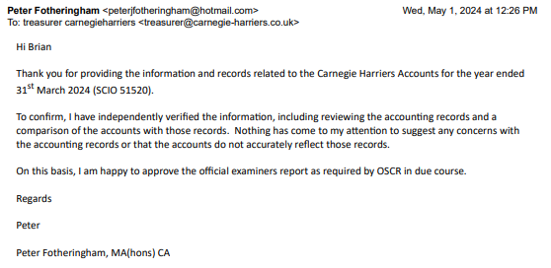

### Appendix #2 – Income and Expenditure Account

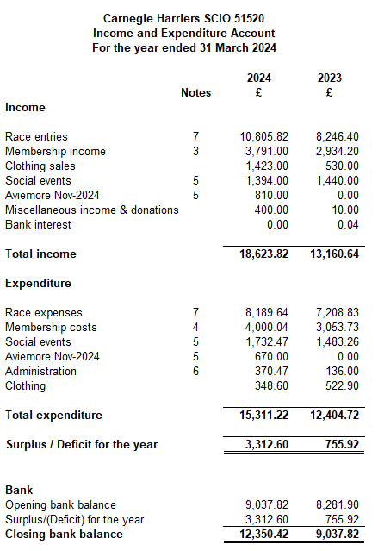

### Appendix #3 – Notes to the Accounts

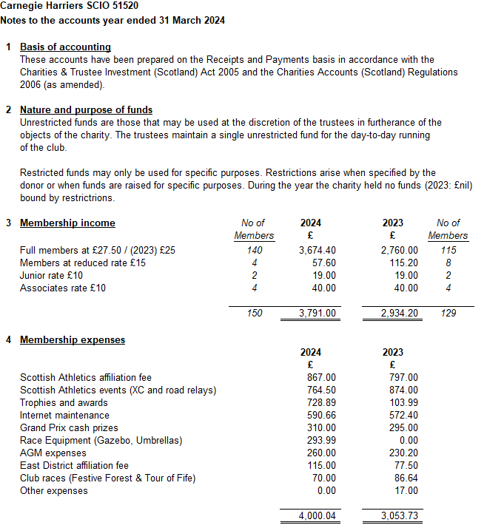

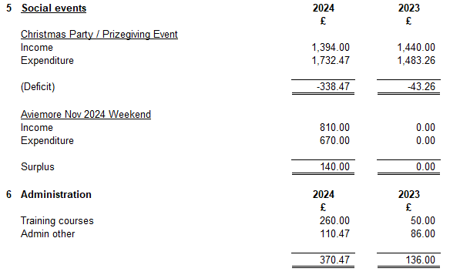

### Appendix #4 – Race Summary

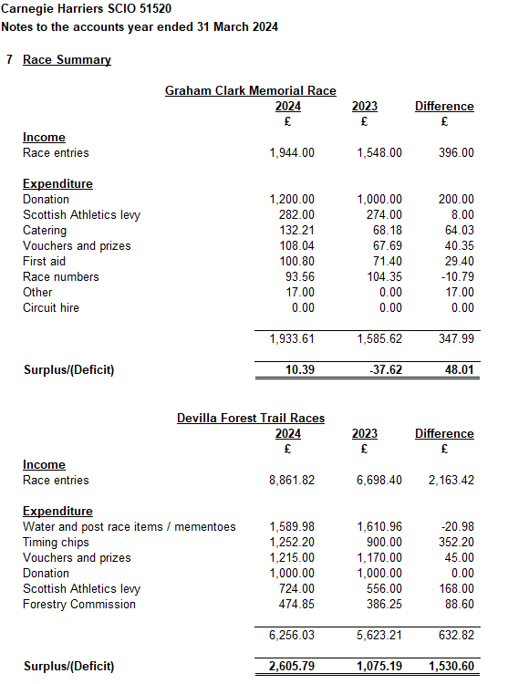

### Appendix #5 – Club Assets (draft)

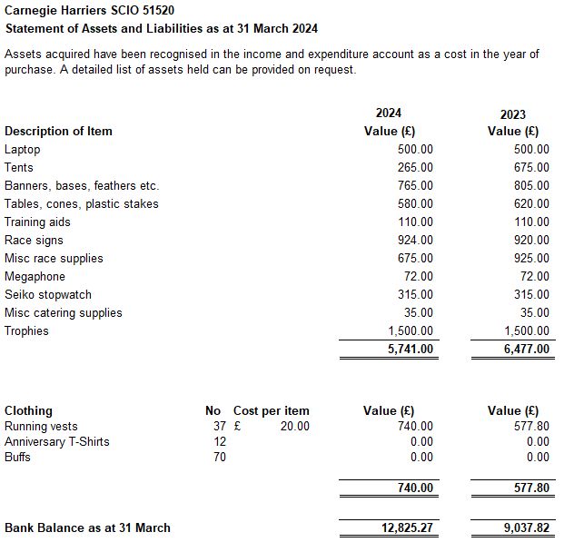

### Appendix #4 – Club Assets

