Carnegie Harriers



Annual Report and Financial Statements

for the

Year ended 31st March 2026

Charity Number SCI0 51520

Carnegie Harriers

Trustees’ Annual Report

Year Ended 31st March 2026

The Board of Trustees have pleasure in presenting their report together with the financial statements and the independent examiner’s report for the year ended 31st March 2026.

Name and Address
Carnegie Harriers c/o 8 The Wellheads, Limekilns, Dunfermline KY11 3JG

Constitution and Purpose
Carnegie Harriers is a Scottish Charitable Incorporated organisation – No SCIO 51520
Carnegie Harriers’ principal objective is:
To encourage and promote participation in the sport of running.

Trustees
Alan Murray President
Sue Walker Secretary
Brian Miller Treasurer
Sarah Wellcoat Welfare Officer
Kevin Spowart
Kerry Hunter
Nils Krichel
Val Macaulay
Sarah Marshall
Gail King
Niall Patterson
Charlotte Briggs

No trustees resigned during the year.
Approved by the Board of Trustees on 8 May 2026 and signed on its behalf by:-

Sue Walker Secretary

CARNEGIE HARRIERS ANNUAL REPORT 2025/26
Membership on 31 March 2026 stood at 134 (130 full and 4 associate members), a 4% decrease on 2025. The club continued to attract new members throughout the year.
In autumn 2025, we launched the third “Couch2Carnegie”, a JogScotland style group aimed at those new to running or looking to get back into the sport. Almost half of those who attended the eight-week programme on a regular basis have now joined the club as full members. Those who chose not to join the club continue to benefit as the C2C leaders remain supportive and keep in touch.
Although the Return to Running group has not formally operated over the past 12 months, members returning after injury, tapering for a big event or otherwise have the option to come along to training and take things easier, perhaps going for a gentle run rather than a full-on training session, and several chose to support the C2C programme as an alternative to a hard training session.
These initiatives complemented our regular twice weekly sessions and we actively encourage prospective new members to come along to our training sessions for several weeks before committing to joining the club. Training is delivered by a training group comprising two Level 2 Coaches in Running Fitness and several Leaders in Running Fitness. The club supports members who wish to work towards these qualifications.
Throughout the year we organised a members’ only competition series embracing road, trail, cross-country and hill races both locally and nationally. The revised format with more local, club organised events and fewer events overall has proved popular with many club members being inspired to try out new races and new types of events. 59 members competed in at least one race in the series. This is slightly lower than previously but, 38 members between them completed 90 races at marathon or ultra distance in the year, perhaps leaving less time for shorter events. The aim is to cater for as wide a range of interests and abilities as possible, and encourage members to try different disciplines, whilst trying to reduce/limit the costs of competing at this time.
During 2025/26 we were able to host both the Graham Clark Memorial Race and the Devilla Trail Races. The Graham Clark race proved very popular and indeed entries sold out in one night, and the new route for both the Devilla 5km and 15km races proved very popular with lots of positive feedback from entrants. In 2025, the cancellation of our popular Devilla Trail races has impacted on the club’s income for the year, and we were pleased to be able to hold the races this year.
The club’s success is due, in large part, to its volunteers. The trustee board has worked on several initiatives to improve communication within the club and promote our activities to a wider audience using social media, as well as overseeing the day-to-day running of the club. Over 60% of club members have volunteered at least once in the past year to support not only club activities but external events as well. Several club members volunteered to train as Leaders in Running Fitness (LIRF) and one member qualified as a Coach in Running Fitness.
Over the coming year, we will continue to work on our training provision, introducing new sessions and training venues and using the pool of LIRF to lead the sessions. We will aim to recruit new members to the club, by catering for different levels of experience and ability and support existing members who may be finding it more difficult to get out and run.

Carnegie Harriers (SCIO 51520) – Treasurer’s Report 2025-26

Treasurer: Brian Miller

Introduction
I hereby present the Treasurer’s Report and Annual Accounts, as independently reviewed by Peter Fotheringham MA (Hons), CA (see Appendix #1).
The Harriers’ financial year follows a consistent pattern, with membership income and race events occurring at the same point of the calendar each year.
The club posted a surplus position this year after the return of our popular Devilla race, which was unfortunately cancelled in the previous year due to storm damage on the course. The return of Devilla income saw the Club post a financial surplus of £764 this year.

Income
Membership income received during the year is as detailed in the Notes to the Accounts (see Appendix #3). The majority of members signed up via Entry Central, where the Club met the 5% Admin Fee.
Membership fees were frozen and remained at the same rate this year.
Our two flagship races were very well attended this year and both generated profits. 100% of the Graham Clark profits (£1,410) were donated to charity, with £1,450 of Devilla profits also being donated. After donations, Devilla generated a surplus of £2,955 to the Club. Therefore, race income for the year was significantly higher versus last year and is the main contributor to this year’s surplus.
Clothing sales were significantly higher this year as we invested in a stock of new vests, which members were keen to purchase and wear at races.
The club organised a social event to Oban in November 2025. Cash was paid to the club by all members planning to attend. This was paid to the Oban Youth Hostel to secure accommodation for the weekend – the event was well attended and self-funded to break even.
The Christmas Social Event was another source of income this year - organised via Entry Central. This was essentially a Not-for-Profit event, but ran a very small surplus this year after we re-used some of the party decorations from last year.

Expenditure
There are a number of membership expenses that are incurred every year as part of the club’s operations. Scottish Athletics Affiliation Fees, GP Prizes, Trophies, Website, etc, and these were much in line with expectations. Overall, membership costs this year were lower than in 2025 (Appendix #3), mainly due to the purchase of a defibrillator and a new club laptop in the previous year.
Expenses for the Graham Clark and Devilla races were in line with budget.
Costs for the aforementioned club vests were a significant item of expenditure this year. Members have purchased these over the year, but we still retain a level of stock should members require a vest at short notice.
Costs were also incurred for the Christmas social event, and these were offset by ticket sales to members.
IT Costs were higher this year, as we changed from a monthly subscription model to an annual payment, leading to a larger upfront payment this year. This will ultimately smooth out over time.

Additionally, we supported a number of members with Training courses this year. Primarily to allow members to lead weekly training sessions.

Independent Review
The independent review was performed remotely via email, with documents shared electronically, consistent with the approach of recent years.

Conclusion
This has been a good year financially for the club, reporting a healthy surplus after last year’s deficit. The surplus funds are reinvested in the club to maintain our long-term financial security. The club will maintain a financial reserve to meet costs and liabilities occurring due to unforeseen circumstances. For example:
- the need to replace club assets if destroyed or damaged;
- unexpected, late cancellation of the Devilla Forest Race.
The club enters 2026-27 in good shape and looks forward to another successful year.
I would like to issue thanks to the trustee board for their support and diligence in ensuring our finances remain so well controlled.

Brian Miller

Appendix #1 – Independent Review
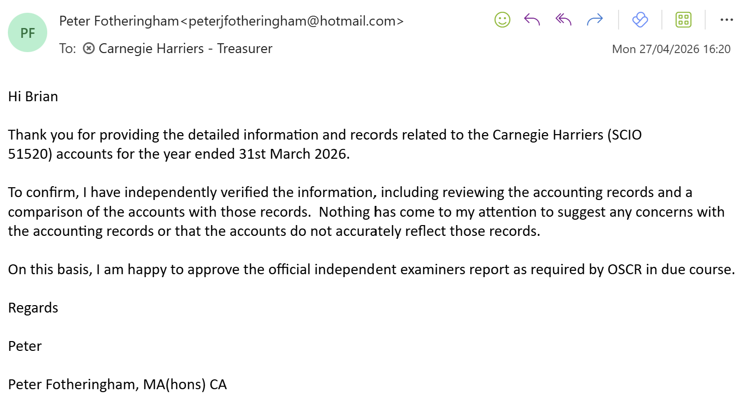

Appendix #2 – Income and Expenditure Account

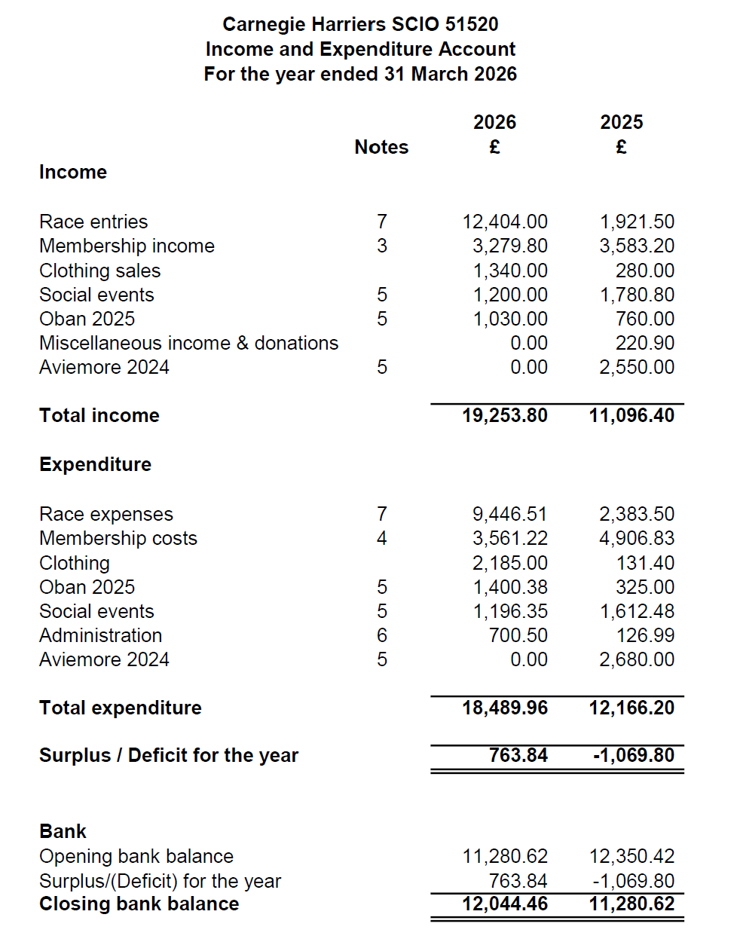

Appendix #3 – Notes to the Accounts
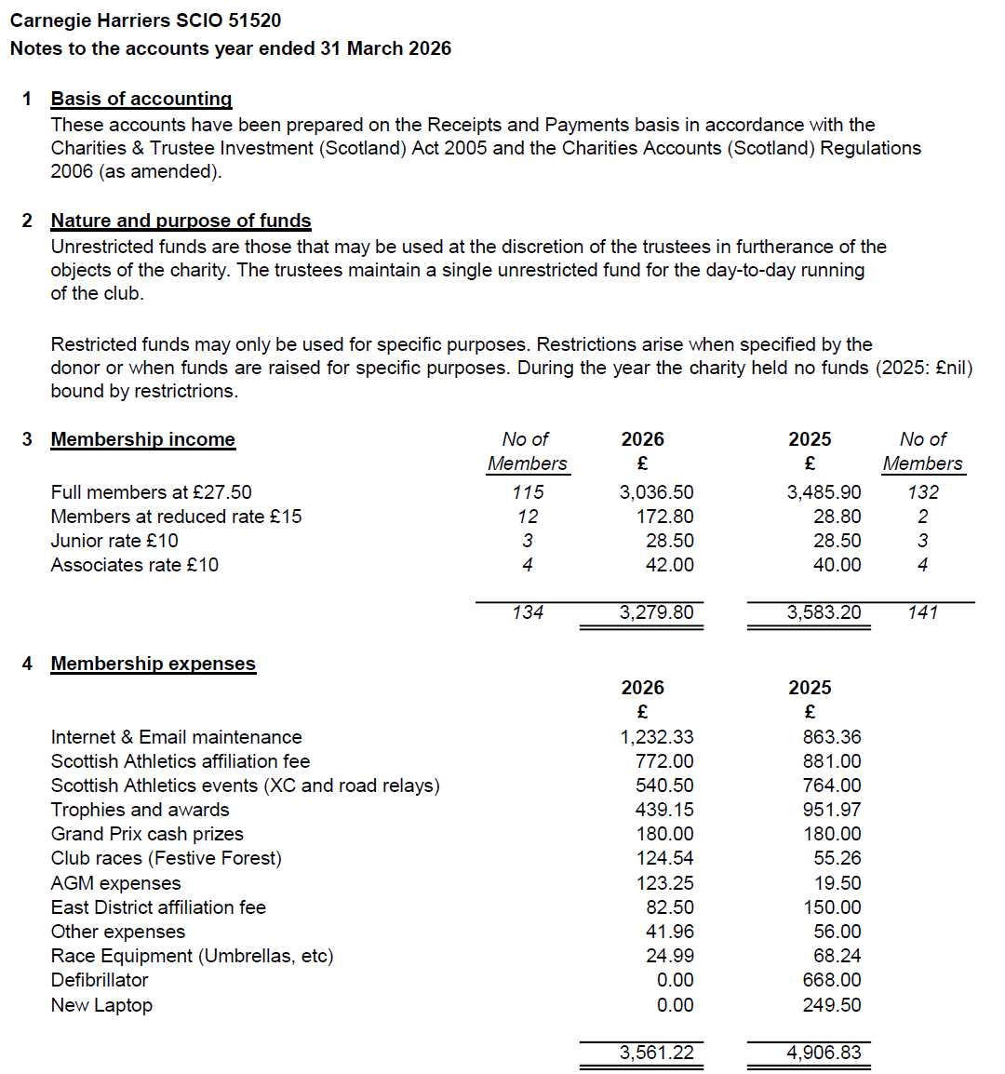

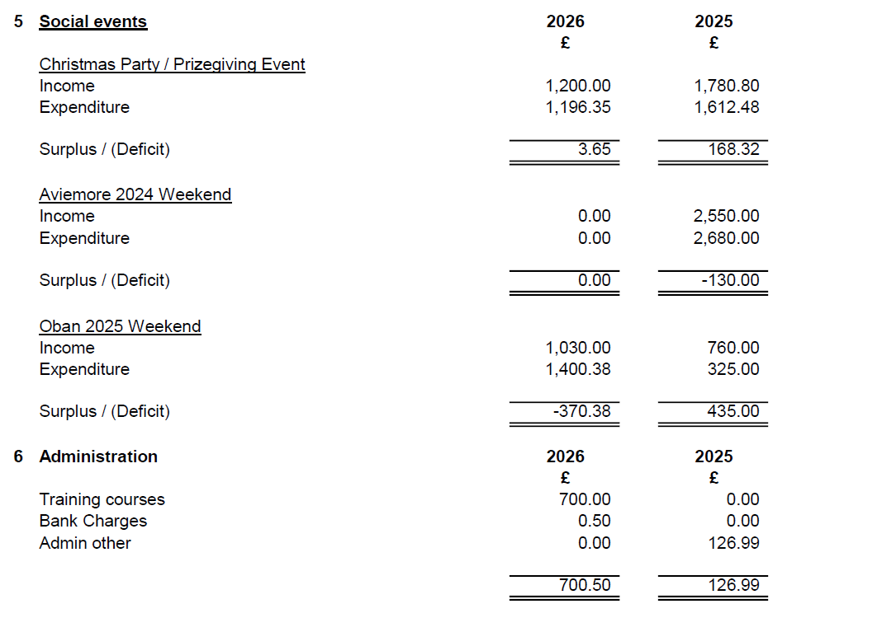

Appendix #4 – Race Summary

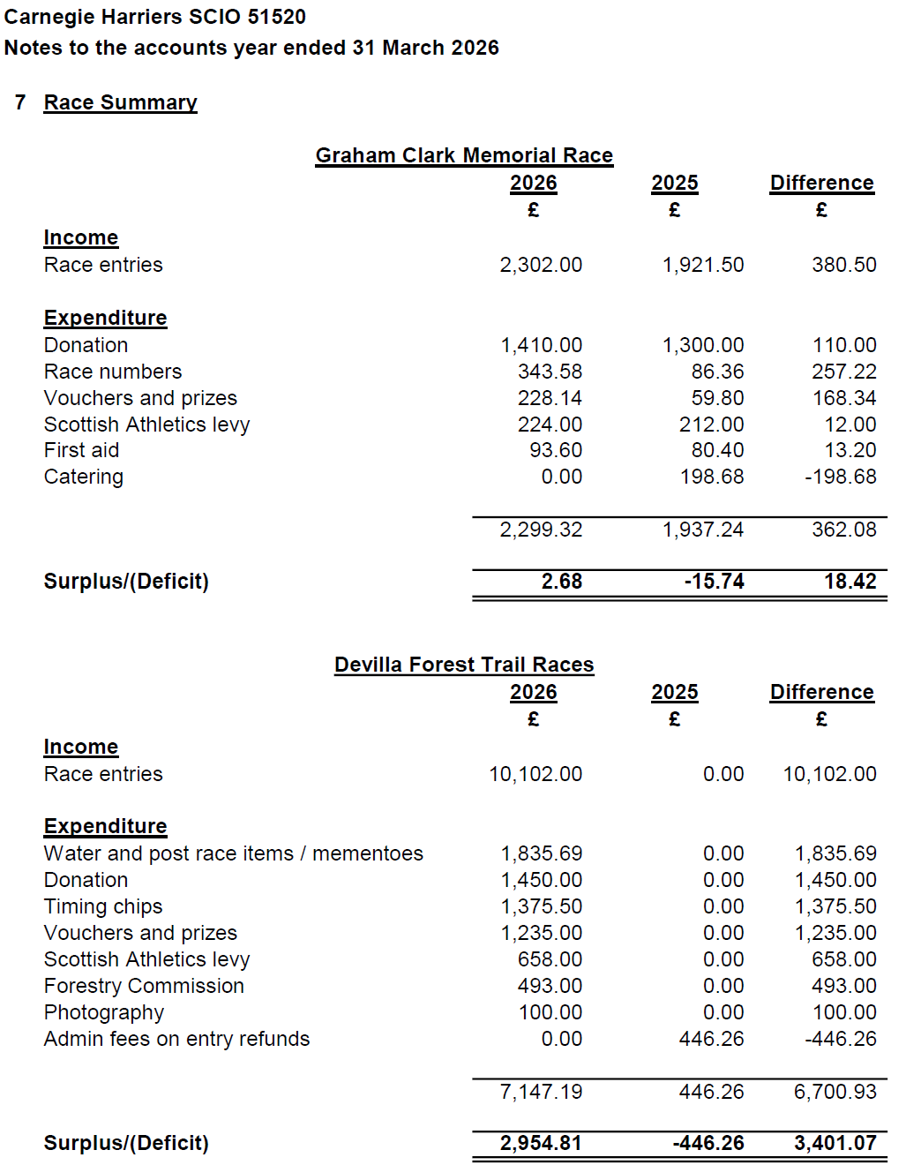

Appendix #5 – Club Assets

